NAME: KRISHANU SOM ROLL NO.: 25BEC034
OBJECTIVE: RTL to GDSII implementation of Parameterized Digital Time Controller
Directory Created: DTC1
Inside DTC1, rtl directory, the following RTL source code is present
`timescale 1ns/1ps
module digital_time_controller #(
parameter N = 8
)(
input wire clk,
input wire rst_n,
input wire enable,
input wire load,
input wire [N-1:0] load_value,
output reg [N-1:0] count,
output reg timeout
);

always @(posedge clk or negedge rst_n) begin
if (!rst_n) begin
count <= {N{1'b0}};
timeout <= 1'b0;
end else begin
timeout <= 1'b0; // default

if (load) begin
count <= load_value;
end
else if (enable) begin
if (count != 0) begin
count <= count - 1'b1;
if (count == 1)
timeout <= 1'b1; // asserted when reaching zero
end
end
end
end

endmodule
Inside rtl simulation directory, source code long with testbench is there
`timescale 1ns/1ps
module tb_digital_time_controller;

parameter N = 8;

reg clk;
reg rst_n;
reg enable;
reg load;
reg [N-1:0] load_value;

wire [N-1:0] count;
wire timeout;

// DUT
digital_time_controller #(
.N(N)
) dut (
.clk(clk),
.rst_n(rst_n),
.enable(enable),
.load(load),
.load_value(load_value),
.count(count),
.timeout(timeout)
);

// Clock (10 ns period)
always #5 clk = ~clk;

initial begin
$dumpfile("dump.vcd"); // VCD file name
$dumpvars(0, tb_digital_time_controller);
// Init
clk = 0;
rst_n = 0;
enable = 0;
load = 0;
load_value = 0;

// Reset
#20 rst_n = 1;

// Load 5
#10;
load = 1;
load_value = 8'd5;

#10;
load = 0;
enable = 1;

// Let it count down
#100;

// Stop
enable = 0;

#20 $finish;
end

initial begin
$display("Time | load enable | load_value | count | timeout");
$monitor("%4t | %b %b | %0d | %0d | %b",
$time, load, enable, load_value, count, timeout);
end

endmodule
The vcs_command file compiles the source code and testbench together in such a format which is executable.
#vcs -full64 dtc_rtl.v -debug_access+all -lca -kdb
vcs -full64 dtc_tb.v -debug_access+all -lca -kdb
./simv Verdi
verdi -ssf novas.fsdb -nologo
The simv file runs the simulation of the code compiled by vcs_command.
Synthesis of RTL code leads to netlist formation.
In DC directory, rm_setup and ICCII directory, scripts, the template scripts given were modified according to parameterized digital time controller.
Then in ICCII directory, icc2_shell, the .tcl scripts of clock, floor planning, placement, power planning, and route were executed and saved in a library [DTC_LIB].
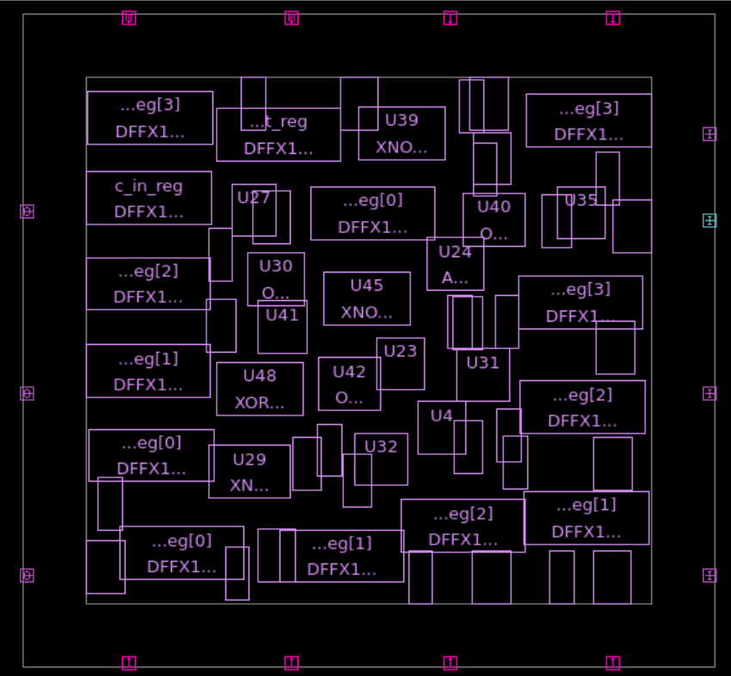
GUI of floor planning

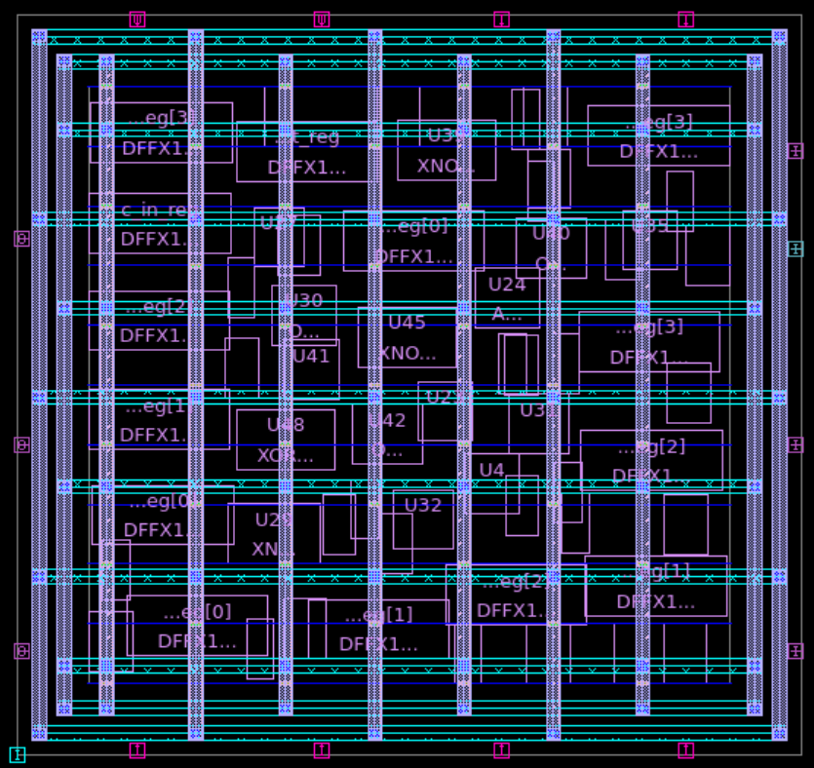
GUI of placement

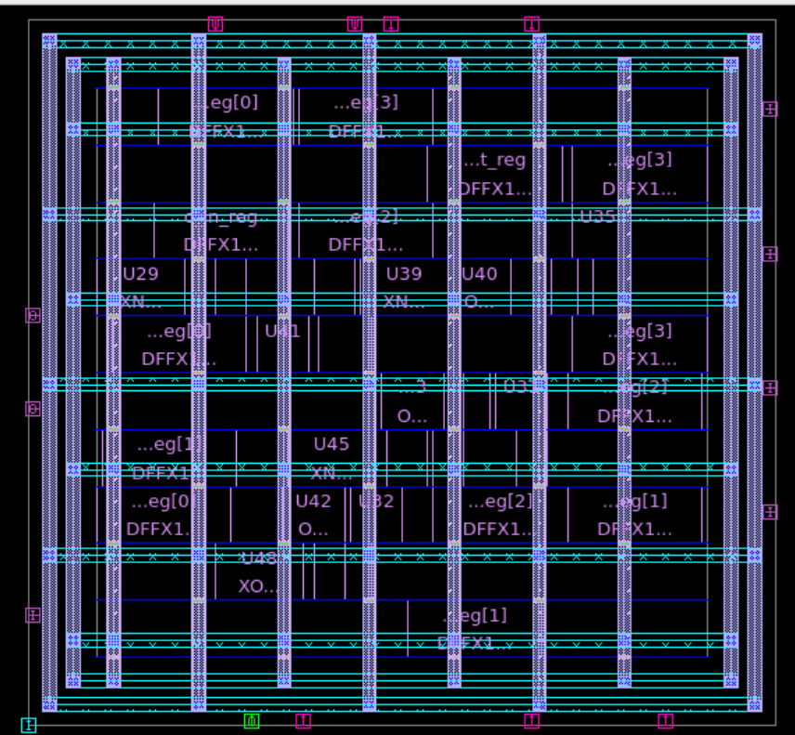
GUI of power planning

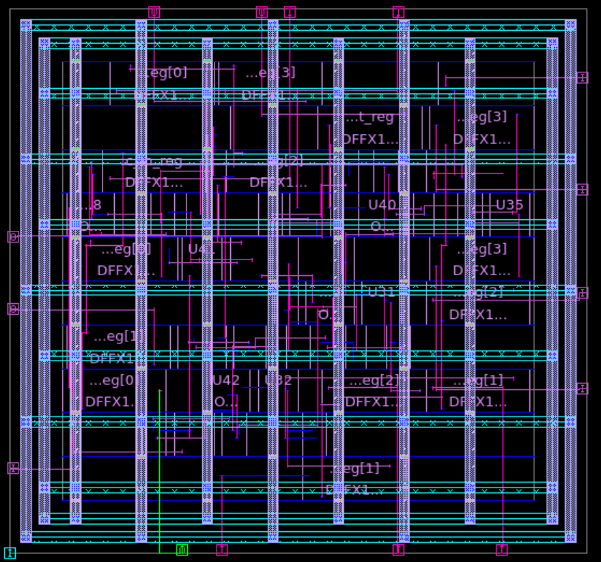
GUI of Clock Tree Synthesis (CTS)

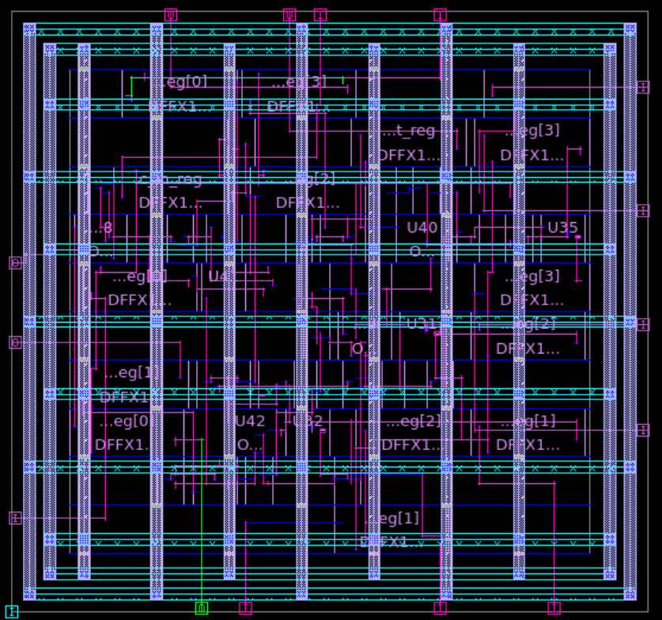
GUI of routed design [GDSII]

